HANDS-ON 1 [Beginner]

Commands Used
npm install -g @angular/cli
ng new student-course-portal --routing --style=css
cd student-course-portal
ng serve
ng build
ng g c components/header
ng g c pages/home
ng g c pages/course-list
ng g c pages/student-profile

Project Structure
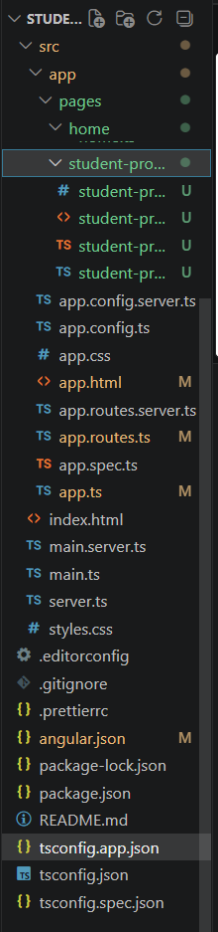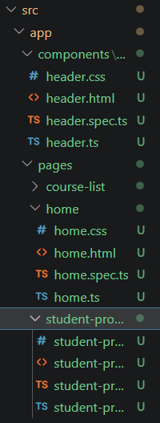

Source Code

header.html
<nav class="navbar">
<h2>Student Course Portal</h2>
<ul>
<li><a routerLink="/">Home</a></li>
<li><a routerLink="/courses">Courses</a></li>
<li><a routerLink="/profile">Profile</a></li>
</ul>
</nav>

header.css
.navbar{
display:flex;
justify-content:space-between;
align-items:center;
background:#1565c0;
padding:15px 40px;
color:white;
}
.navbar ul{
display:flex;
gap:25px;
list-style:none;
}
.navbar a{
color:white;
text-decoration:none;
}

home.html
<h1>Welcome to Student Course Portal</h1>
<p>Manage your academic journey from one place.</p>
<div class="stats">
<div class="card">
<h3>Courses Available</h3>
<p>12</p>
</div>
<div class="card">
<h3>Enrolled</h3>
<p>3</p>
</div>
<div class="card">
<h3>GPA</h3>
<p>3.8</p>
</div>
</div>

home.css
.stats{
display:flex;
gap:20px;
margin-top:30px;
}
.card{
width:200px;
padding:20px;
border-radius:10px;
border:1px solid #ccc;
text-align:center;
box-shadow:0 2px 8px rgba(0,0,0,.15);
}

app.routes.ts
import { Routes } from '@angular/router';
import { HomeComponent } from './pages/home/home';
export const routes: Routes = [
{ path:'', component: HomeComponent }
];

app.html
<app-header></app-header>
<router-outlet></router-outlet>

Output
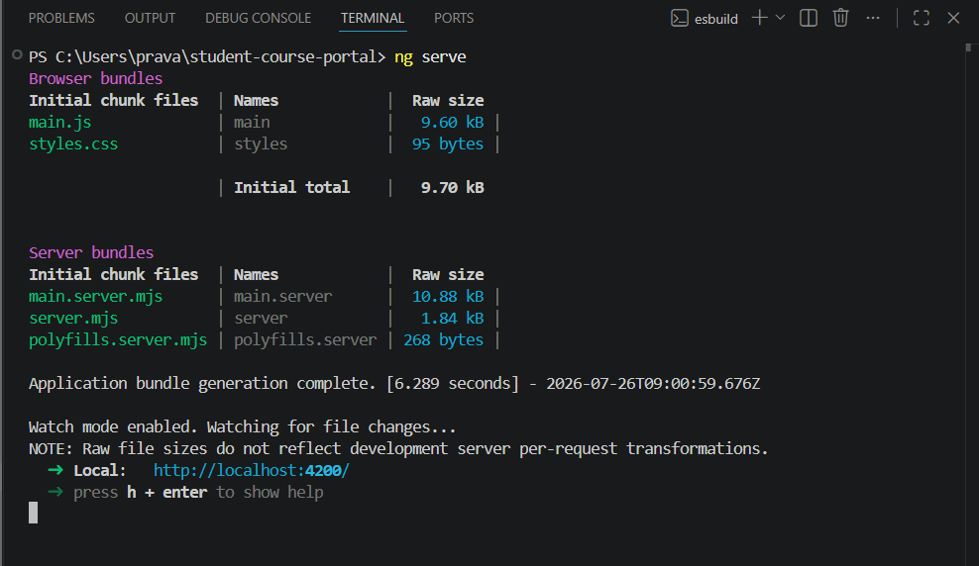

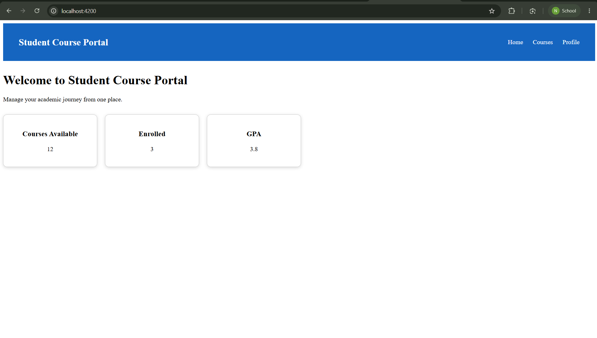Learning Outcome
Learned Angular CLI, project creation, standalone project structure, components, routing basics, HTML templates, CSS styling, and project execution.

